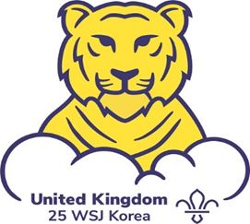

World Scout Jamboree 2023

The County International Team are looking to recruit a new deputy Leader for Unit 24 that will be travelling to the World Jamboree on the 26th of July 2023 and returning on 16th of August 2023.
The Unit has been meeting for over a year and the successful applicant will need to be able to fit in with an existing Leader team and be flexible, adaptable, and well-motivated.
Previous International experience or experience of going to a Jamboree may be helpful but is not essential and applicants can come from any section in Hertfordshire Scouts, we currently have Beaver Leaders, Cub Leaders, Scout Leaders, and Network members in the Leader Teams of the three Hertfordshire Units.
The next World Jamboree is the 25th and takes place at SaeManGeum, Buan-gun in South Korea and there will be 40,000 Scouts and Leaders taking part in this amazing event.
The theme of the Jamboree is “draw your dream” and the event is being planned and organised by the Korea Scout Association.
Participation in a World Jamboree is a life changing experience for the participants and Leaders alike and Leadership roles are very sought after, so please do not miss this opportunity to apply.
Attached is a link to the job specification, application form, equal opportunity monitoring document. Applications must be submitted by Sunday 12th February.
If you have any questions, please contact Peter Makewell either by email or mobile phone on 07931 543 185 and Peter will respond as quickly as possible.

Please send email replies to peter.makewell@hertfordshirescouts.org or postal replies can go to:

World Scout Jamboree 2023
Hertfordshire Scouts
County Office
Phasels Wood
Rucklers Lane
Kings Langley
Hertfordshire
WD4 9NA

Good Luck with your application.

